|  |
| --- |
|  |
| The Documentation |
| [Type the document subtitle] |
|  |
| **[Your Name]** |
| **[Pick the date]** |

[Type the abstract of the document here. The abstract is typically a short summary of the contents of the document. Type the abstract of the document here. The abstract is typically a short summary of the contents of the document.]

Table of Contents

[To update the table of contents, right click the message below and select Update Field (F9 on PC, ⌥⌘U on Mac).]

**No table of contents entries found.**

1. Pages
   1. Page Tree

Главная  
 Каталог товаров  
 Название товара по категориям 1 вид  
 Название товара по категориям 2 вид  
 Описание товара  
 Описание ранее порсматриваемого товара  
 Новые поступления  
 Специальное предложение  
 О компании  
 Статьи  
 Статья подробнее  
 Контакты  
 Карта сайта

* 1. Главная
     1. User Interface

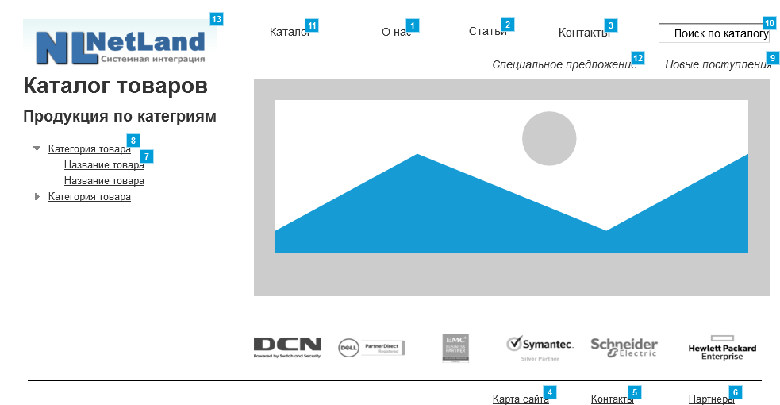

* + 1. Widget Table

|  |  |  |
| --- | --- | --- |
| Footnote | Name | Interactions |
| 1 |  | OnClick:  Case 1:  Open О компании in Current Window |
| 2 |  | OnClick:  Case 1:  Open Статьи in Current Window |
| 3 |  | OnClick:  Case 1:  Open Контакты in Current Window |
| 4 |  | OnClick:  Case 1:  Open Карта сайта in Current Window |
| 5 |  | OnClick:  Case 1:  Open Контакты in Current Window |
| 6 |  | OnClick:  Case 1:  Open О компании in Current Window |
| 7 |  | OnClick:  Case 1:  Open Название товара по категориям 1 вид in Current Window |
| 8 |  | OnClick:  Case 1:  Open Link in Current Window  Open Название товара по категориям 1 вид in Current Window |
| 9 |  | OnClick:  Case 1:  Open Новые поступления in Current Window |
| 10 |  | OnClick:  Case 1:  Open Описание товара in Current Window |
| 11 |  | OnClick:  Case 1:  Open Каталог товаров in Current Window OnMouseEnter:  Case 1:  Open Link in Current Window  Show/Hide Widget  Show flowout menu treat as flyout |
| 12 |  | OnClick:  Case 1:  Open Специальное предложение in Current Window |
| 13 |  | OnClick:  Case 1:  Open Главная in Current Window |

* + 1. flowout menu
       1. State1
       2. User Interface



* + - 1. Widget Table

|  |  |
| --- | --- |
| Footnote | Interactions |
| 1 | OnClick:  Case 1:  Open Каталог товаров in Current Window |
| 2 | OnClick:  Case 1:  Open Каталог товаров in Current Window |

* 1. Каталог товаров
     1. User Interface

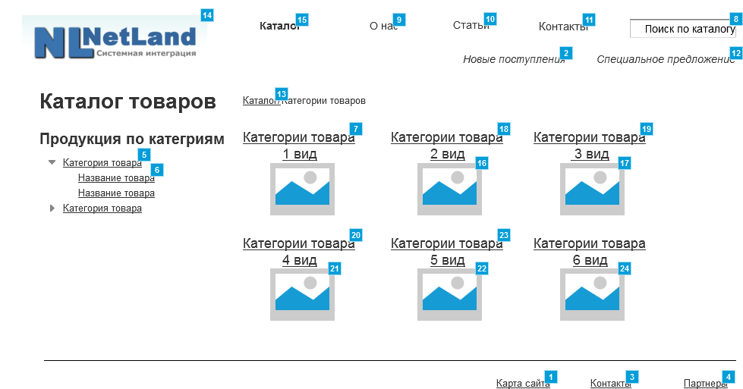

* + 1. Widget Table

|  |  |  |
| --- | --- | --- |
| Footnote | Name | Interactions |
| 1 |  | OnClick:  Case 1:  Open Карта сайта in Current Window |
| 2 |  | OnClick:  Case 1:  Open Новые поступления in Current Window |
| 3 |  | OnClick:  Case 1:  Open Контакты in Current Window |
| 4 |  | OnClick:  Case 1:  Open О компании in Current Window |
| 5 |  | OnClick:  Case 1:  Open Link in Current Window  Open Название товара по категориям 1 вид in Current Window |
| 6 |  | OnClick:  Case 1:  Open Название товара по категориям 1 вид in Current Window |
| 7 |  | OnClick:  Case 1:  Open Название товара по категориям 1 вид in Current Window |
| 8 |  | OnClick:  Case 1:  Open Link in Current Window  Open Описание товара in Current Window |
| 9 |  | OnClick:  Case 1:  Open О компании in Current Window |
| 10 |  | OnClick:  Case 1:  Open Статьи in Current Window |
| 11 |  | OnClick:  Case 1:  Open Контакты in Current Window |
| 12 |  | OnClick:  Case 1:  Open Link in Current Window  Open Специальное предложение in Current Window |
| 13 |  | OnClick:  Case 1:  Open Каталог товаров in Current Window |
| 14 |  | OnClick:  Case 1:  Open Главная in Current Window |
| 15 |  | OnClick:  Case 1:  Open Каталог товаров in Current Window OnMouseEnter:  Case 1:  Open Link in Current Window  Show/Hide Widget  Show flowout menu treat as flyout |
| 16 |  | OnClick:  Case 1:  Open Название товара по категориям 1 вид in Current Window |
| 17 |  | OnClick:  Case 1:  Open Название товара по категориям 1 вид in Current Window |
| 18 |  | OnClick:  Case 1:  Open Название товара по категориям 1 вид in Current Window |
| 19 |  | OnClick:  Case 1:  Open Link in Current Window  Open Название товара по категориям 1 вид in Current Window |
| 20 |  | OnClick:  Case 1:  Open Название товара по категориям 1 вид in Current Window |
| 21 |  | OnClick:  Case 1:  Open Название товара по категориям 1 вид in Current Window |
| 22 |  | OnClick:  Case 1:  Open Название товара по категориям 1 вид in Current Window |
| 23 |  | OnClick:  Case 1:  Open Название товара по категориям 1 вид in Current Window |
| 24 |  | OnClick:  Case 1:  Open Название товара по категориям 1 вид in Current Window |

* + 1. flowout menu
       1. State1
       2. User Interface



* + - 1. Widget Table

|  |  |
| --- | --- |
| Footnote | Interactions |
| 1 | OnClick:  Case 1:  Open Каталог товаров in Current Window |
| 2 | OnClick:  Case 1:  Open Каталог товаров in Current Window |

* 1. Название товара по категориям 1 вид
     1. User Interface

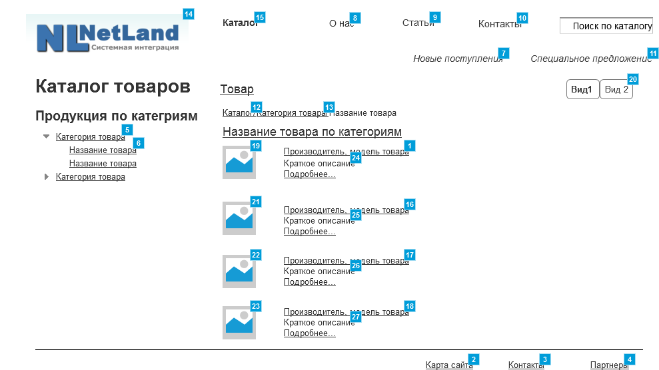

* + 1. Widget Table

|  |  |  |
| --- | --- | --- |
| Footnote | Name | Interactions |
| 1 |  | OnClick:  Case 1:  Open Описание товара in Current Window |
| 2 |  | OnClick:  Case 1:  Open Карта сайта in Current Window |
| 3 |  | OnClick:  Case 1:  Open Контакты in Current Window |
| 4 |  | OnClick:  Case 1:  Open О компании in Current Window |
| 5 |  | OnClick:  Case 1:  Open Каталог товаров in Current Window |
| 6 |  | OnClick:  Case 1:  Open Название товара по категориям 1 вид in Current Window |
| 7 |  | OnClick:  Case 1:  Open Новые поступления in Current Window |
| 8 |  | OnClick:  Case 1:  Open О компании in Current Window |
| 9 |  | OnClick:  Case 1:  Open Статьи in Current Window |
| 10 |  | OnClick:  Case 1:  Open Контакты in Current Window |
| 11 |  | OnClick:  Case 1:  Open Специальное предложение in Current Window |
| 12 |  | OnClick:  Case 1:  Open Каталог товаров in Current Window |
| 13 |  | OnClick:  Case 1:  Open Link in Current Window  Open Название товара по категориям 1 вид in Current Window |
| 14 |  | OnClick:  Case 1:  Open Главная in Current Window |
| 15 |  | OnClick:  Case 1:  Open Каталог товаров in Current Window OnMouseEnter:  Case 1:  Open Link in Current Window  Show/Hide Widget  Show flowout menu treat as flyout |
| 16 |  | OnClick:  Case 1:  Open Описание товара in Current Window |
| 17 |  | OnClick:  Case 1:  Open Описание товара in Current Window |
| 18 |  | OnClick:  Case 1:  Open Описание товара in Current Window |
| 19 |  | OnClick:  Case 1:  Open Описание товара in Current Window |
| 20 |  | OnClick:  Case 1:  Open Название товара по категориям 2 вид in Current Window |
| 21 |  | OnClick:  Case 1:  Open Описание товара in Current Window |
| 22 |  | OnClick:  Case 1:  Open Описание товара in Current Window |
| 23 |  | OnClick:  Case 1:  Open Описание товара in Current Window |
| 24 |  | OnClick:  Case 1:  Open Описание товара in Current Window |
| 25 |  | OnClick:  Case 1:  Open Описание товара in Current Window |
| 26 |  | OnClick:  Case 1:  Open Описание товара in Current Window |
| 27 |  | OnClick:  Case 1:  Open Описание товара in Current Window |

* + 1. flowout menu
       1. State1
       2. User Interface



* + - 1. Widget Table

|  |  |
| --- | --- |
| Footnote | Interactions |
| 1 | OnClick:  Case 1:  Open Каталог товаров in Current Window |
| 2 | OnClick:  Case 1:  Open Каталог товаров in Current Window |

* 1. Название товара по категориям 2 вид
     1. User Interface

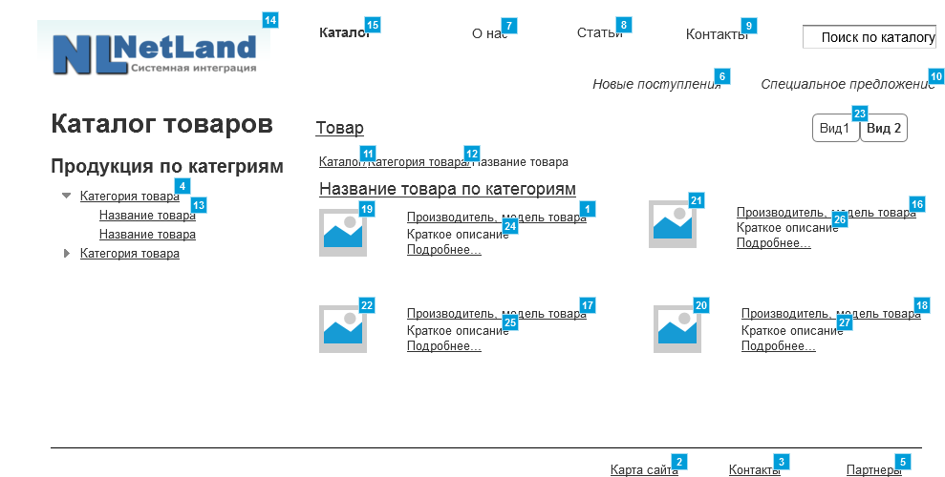

* + 1. Widget Table

|  |  |  |
| --- | --- | --- |
| Footnote | Name | Interactions |
| 1 |  | OnClick:  Case 1:  Open Описание товара in Current Window |
| 2 |  | OnClick:  Case 1:  Open Карта сайта in Current Window |
| 3 |  | OnClick:  Case 1:  Open Контакты in Current Window |
| 4 |  | OnClick:  Case 1:  Open Каталог товаров in Current Window |
| 5 |  | OnClick:  Case 1:  Open О компании in Current Window |
| 6 |  | OnClick:  Case 1:  Open Новые поступления in Current Window |
| 7 |  | OnClick:  Case 1:  Open О компании in Current Window |
| 8 |  | OnClick:  Case 1:  Open Статьи in Current Window |
| 9 |  | OnClick:  Case 1:  Open Контакты in Current Window |
| 10 |  | OnClick:  Case 1:  Open Специальное предложение in Current Window |
| 11 |  | OnClick:  Case 1:  Open Каталог товаров in Current Window |
| 12 |  | OnClick:  Case 1:  Open Link in Current Window  Open Название товара по категориям 1 вид in Current Window |
| 13 |  | OnClick:  Case 1:  Open Название товара по категориям 1 вид in Current Window |
| 14 |  | OnClick:  Case 1:  Open Главная in Current Window |
| 15 |  | OnClick:  Case 1:  Open Каталог товаров in Current Window OnMouseEnter:  Case 1:  Open Link in Current Window  Show/Hide Widget  Show flowout menu treat as flyout |
| 16 |  | OnClick:  Case 1:  Open Описание товара in Current Window |
| 17 |  | OnClick:  Case 1:  Open Описание товара in Current Window |
| 18 |  | OnClick:  Case 1:  Open Описание товара in Current Window |
| 19 |  | OnClick:  Case 1:  Open Описание товара in Current Window |
| 20 |  | OnClick:  Case 1:  Open Описание товара in Current Window |
| 21 |  | OnClick:  Case 1:  Open Описание товара in Current Window |
| 22 |  | OnClick:  Case 1:  Open Описание товара in Current Window |
| 23 |  | OnClick:  Case 1:  Open Название товара по категориям 1 вид in Current Window |
| 24 |  | OnClick:  Case 1:  Open Описание товара in Current Window |
| 25 |  | OnClick:  Case 1:  Open Описание товара in Current Window |
| 26 |  | OnClick:  Case 1:  Open Описание товара in Current Window |
| 27 |  | OnClick:  Case 1:  Open Описание товара in Current Window |

* + 1. flowout menu
       1. State1
       2. User Interface



* + - 1. Widget Table

|  |  |
| --- | --- |
| Footnote | Interactions |
| 1 | OnClick:  Case 1:  Open Каталог товаров in Current Window |
| 2 | OnClick:  Case 1:  Open Каталог товаров in Current Window |

* 1. Описание товара
     1. User Interface

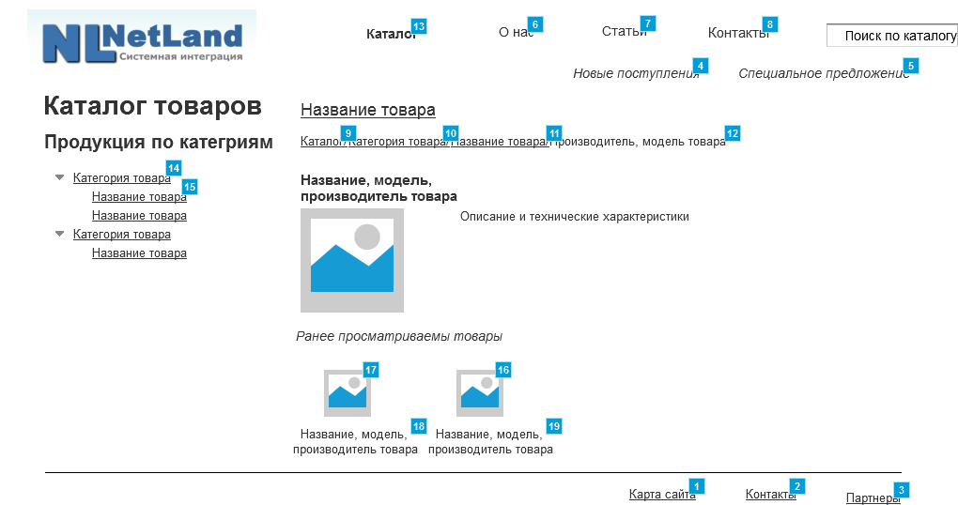

* + 1. Widget Table

|  |  |  |
| --- | --- | --- |
| Footnote | Name | Interactions |
| 1 |  | OnClick:  Case 1:  Open Карта сайта in Current Window |
| 2 |  | OnClick:  Case 1:  Open Контакты in Current Window |
| 3 |  | OnClick:  Case 1:  Open О компании in Current Window |
| 4 |  | OnClick:  Case 1:  Open Новые поступления in Current Window |
| 5 |  | OnClick:  Case 1:  Open Специальное предложение in Current Window |
| 6 |  | OnClick:  Case 1:  Open О компании in Current Window |
| 7 |  | OnClick:  Case 1:  Open Статьи in Current Window |
| 8 |  | OnClick:  Case 1:  Open Контакты in Current Window |
| 9 |  | OnClick:  Case 1:  Open Каталог товаров in Current Window |
| 10 |  | OnClick:  Case 1:  Open Link in Current Window  Open Название товара по категориям 1 вид in Current Window |
| 11 |  | OnClick:  Case 1:  Open Название товара по категориям 1 вид in Current Window |
| 12 |  | OnClick:  Case 1:  Open Главная in Current Window |
| 13 |  | OnClick:  Case 1:  Open Каталог товаров in Current Window OnMouseEnter:  Case 1:  Open Link in Current Window  Show/Hide Widget  Show flowout menu treat as flyout |
| 14 |  | OnClick:  Case 1:  Open Название товара по категориям 1 вид in Current Window |
| 15 |  | OnClick:  Case 1:  Open Название товара по категориям 1 вид in Current Window |
| 16 |  | OnClick:  Case 1:  Open Описание ранее порсматриваемого товара in Current Window |
| 17 |  | OnClick:  Case 1:  Open Описание ранее порсматриваемого товара in Current Window |
| 18 |  | OnClick:  Case 1:  Open Описание ранее порсматриваемого товара in Current Window |
| 19 |  | OnClick:  Case 1:  Open Описание ранее порсматриваемого товара in Current Window |

* + 1. flowout menu
       1. State1
       2. User Interface



* + - 1. Widget Table

|  |  |
| --- | --- |
| Footnote | Interactions |
| 1 | OnClick:  Case 1:  Open Каталог товаров in Current Window |
| 2 | OnClick:  Case 1:  Open Каталог товаров in Current Window |

* 1. Описание ранее порсматриваемого товара
     1. User Interface

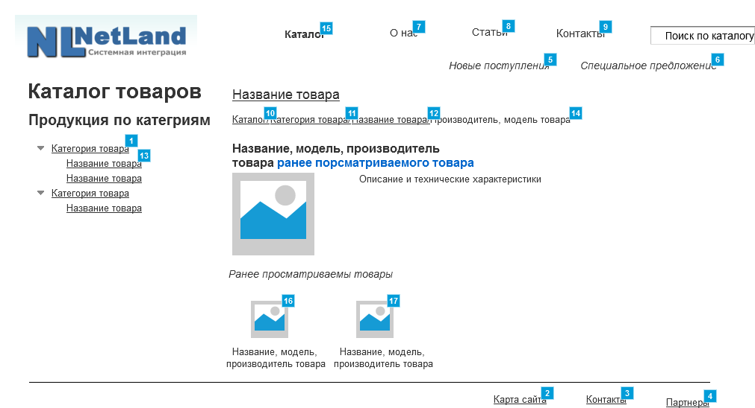

* + 1. Widget Table

|  |  |  |
| --- | --- | --- |
| Footnote | Name | Interactions |
| 1 |  | OnClick:  Case 1:  Open Название товара по категориям 1 вид in Current Window |
| 2 |  | OnClick:  Case 1:  Open Карта сайта in Current Window |
| 3 |  | OnClick:  Case 1:  Open Контакты in Current Window |
| 4 |  | OnClick:  Case 1:  Open О компании in Current Window |
| 5 |  | OnClick:  Case 1:  Open Новые поступления in Current Window |
| 6 |  | OnClick:  Case 1:  Open Специальное предложение in Current Window |
| 7 |  | OnClick:  Case 1:  Open О компании in Current Window |
| 8 |  | OnClick:  Case 1:  Open Статьи in Current Window |
| 9 |  | OnClick:  Case 1:  Open Контакты in Current Window |
| 10 |  | OnClick:  Case 1:  Open Каталог товаров in Current Window |
| 11 |  | OnClick:  Case 1:  Open Link in Current Window  Open Название товара по категориям 1 вид in Current Window |
| 12 |  | OnClick:  Case 1:  Open Название товара по категориям 1 вид in Current Window |
| 13 |  | OnClick:  Case 1:  Open Название товара по категориям 1 вид in Current Window |
| 14 |  | OnClick:  Case 1:  Open Главная in Current Window |
| 15 |  | OnClick:  Case 1:  Open Каталог товаров in Current Window OnMouseEnter:  Case 1:  Open Link in Current Window  Show/Hide Widget  Show flowout menu treat as flyout |
| 16 |  | OnClick:  Case 1:  Open Описание товара in Current Window |
| 17 |  | OnClick:  Case 1:  Open Описание товара in Current Window |

* + 1. flowout menu
       1. State1
       2. User Interface



* + - 1. Widget Table

|  |  |
| --- | --- |
| Footnote | Interactions |
| 1 | OnClick:  Case 1:  Open Каталог товаров in Current Window |
| 2 | OnClick:  Case 1:  Open Каталог товаров in Current Window |

* 1. Новые поступления
     1. User Interface

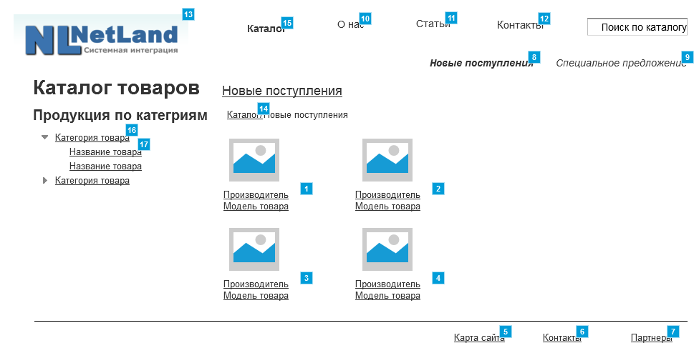

* + 1. Widget Table

|  |  |  |
| --- | --- | --- |
| Footnote | Name | Interactions |
| 1 |  | OnClick:  Case 1:  Open Описание товара in Current Window |
| 2 |  | OnClick:  Case 1:  Open Описание товара in Current Window |
| 3 |  | OnClick:  Case 1:  Open Описание товара in Current Window |
| 4 |  | OnClick:  Case 1:  Open Описание товара in Current Window |
| 5 |  | OnClick:  Case 1:  Open Карта сайта in Current Window |
| 6 |  | OnClick:  Case 1:  Open Контакты in Current Window |
| 7 |  | OnClick:  Case 1:  Open О компании in Current Window |
| 8 |  | OnClick:  Case 1:  Open Новые поступления in Current Window |
| 9 |  | OnClick:  Case 1:  Open Специальное предложение in Current Window |
| 10 |  | OnClick:  Case 1:  Open О компании in Current Window |
| 11 |  | OnClick:  Case 1:  Open Статьи in Current Window |
| 12 |  | OnClick:  Case 1:  Open Контакты in Current Window |
| 13 |  | OnClick:  Case 1:  Open Главная in Current Window |
| 14 |  | OnClick:  Case 1:  Open Каталог товаров in Current Window |
| 15 |  | OnClick:  Case 1:  Open Каталог товаров in Current Window OnMouseEnter:  Case 1:  Open Link in Current Window  Show/Hide Widget  Show flowout menu treat as flyout |
| 16 |  | OnClick:  Case 1:  Open Каталог товаров in Current Window |
| 17 |  | OnClick:  Case 1:  Open Название товара по категориям 1 вид in Current Window |

* + 1. flowout menu
       1. State1
       2. User Interface



* + - 1. Widget Table

|  |  |
| --- | --- |
| Footnote | Interactions |
| 1 | OnClick:  Case 1:  Open Каталог товаров in Current Window |
| 2 | OnClick:  Case 1:  Open Каталог товаров in Current Window |

* 1. Специальное предложение
     1. User Interface

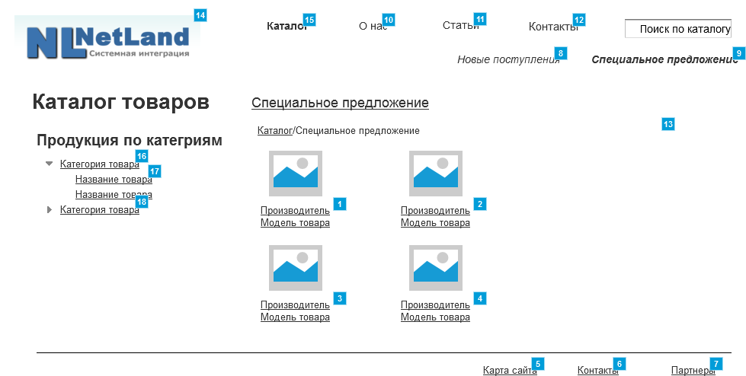

* + 1. Widget Table

|  |  |  |
| --- | --- | --- |
| Footnote | Name | Interactions |
| 1 |  | OnClick:  Case 1:  Open Описание товара in Current Window |
| 2 |  | OnClick:  Case 1:  Open Описание товара in Current Window |
| 3 |  | OnClick:  Case 1:  Open Описание товара in Current Window |
| 4 |  | OnClick:  Case 1:  Open Описание товара in Current Window |
| 5 |  | OnClick:  Case 1:  Open Карта сайта in Current Window |
| 6 |  | OnClick:  Case 1:  Open Контакты in Current Window |
| 7 |  | OnClick:  Case 1:  Open О компании in Current Window |
| 8 |  | OnClick:  Case 1:  Open Новые поступления in Current Window |
| 9 |  | OnClick:  Case 1:  Open Link in Current Window |
| 10 |  | OnClick:  Case 1:  Open О компании in Current Window |
| 11 |  | OnClick:  Case 1:  Open Статьи in Current Window |
| 12 |  | OnClick:  Case 1:  Open Контакты in Current Window |
| 13 |  | OnClick:  Case 1:  Open Каталог товаров in Current Window |
| 14 |  | OnClick:  Case 1:  Open Главная in Current Window |
| 15 |  | OnClick:  Case 1:  Open Каталог товаров in Current Window OnMouseEnter:  Case 1:  Open Link in Current Window  Show/Hide Widget  Show flowout menu treat as flyout |
| 16 |  | OnClick:  Case 1:  Open Каталог товаров in Current Window |
| 17 |  | OnClick:  Case 1:  Open Название товара по категориям 1 вид in Current Window |
| 18 |  | OnClick:  Case 1:  Open Каталог товаров in Current Window |

* + 1. flowout menu
       1. State1
       2. User Interface



* + - 1. Widget Table

|  |  |
| --- | --- |
| Footnote | Interactions |
| 1 | OnClick:  Case 1:  Open Каталог товаров in Current Window |
| 2 | OnClick:  Case 1:  Open Каталог товаров in Current Window |

* 1. О компании
     1. User Interface

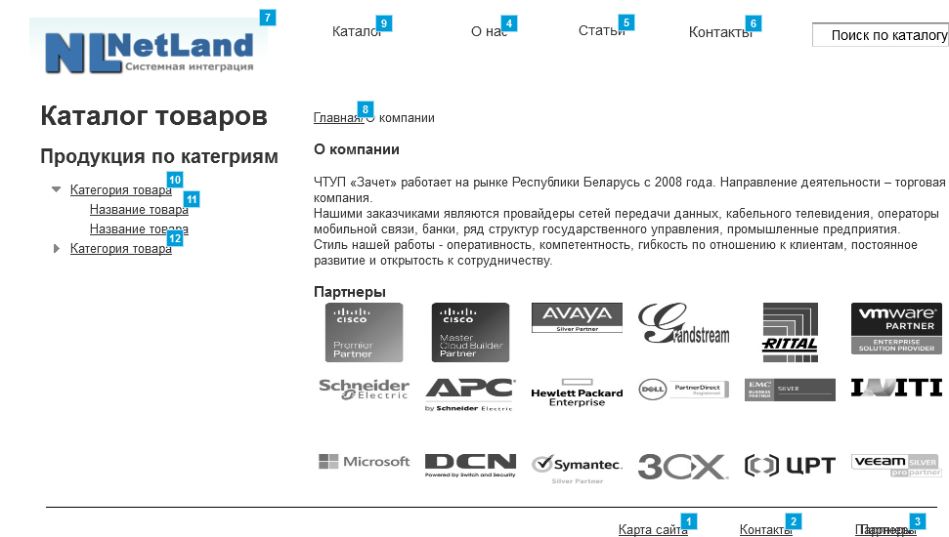

* + 1. Widget Table

|  |  |  |
| --- | --- | --- |
| Footnote | Name | Interactions |
| 1 |  | OnClick:  Case 1:  Open Карта сайта in Current Window |
| 2 |  | OnClick:  Case 1:  Open Контакты in Current Window |
| 3 |  | OnClick:  Case 1:  Open О компании in Current Window |
| 4 |  | OnClick:  Case 1:  Open О компании in Current Window |
| 5 |  | OnClick:  Case 1:  Open Статьи in Current Window |
| 6 |  | OnClick:  Case 1:  Open Контакты in Current Window |
| 7 |  | OnClick:  Case 1:  Open Главная in Current Window |
| 8 |  | OnClick:  Case 1:  Open Главная in Current Window |
| 9 |  | OnClick:  Case 1:  Open Каталог товаров in Current Window OnMouseEnter:  Case 1:  Open Link in Current Window  Show/Hide Widget  Show flowout menu treat as flyout |
| 10 |  | OnClick:  Case 1:  Open Каталог товаров in Current Window |
| 11 |  | OnClick:  Case 1:  Open Название товара по категориям 1 вид in Current Window |
| 12 |  | OnClick:  Case 1:  Open Каталог товаров in Current Window |

* + 1. flowout menu
       1. State1
       2. User Interface



* + - 1. Widget Table

|  |  |
| --- | --- |
| Footnote | Interactions |
| 1 | OnClick:  Case 1:  Open Каталог товаров in Current Window |
| 2 | OnClick:  Case 1:  Open Каталог товаров in Current Window |

* 1. Статьи
     1. User Interface

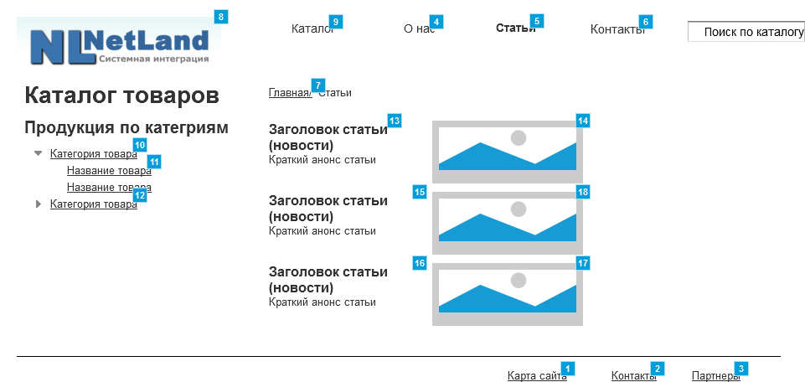

* + 1. Widget Table

|  |  |  |
| --- | --- | --- |
| Footnote | Name | Interactions |
| 1 |  | OnClick:  Case 1:  Open Карта сайта in Current Window |
| 2 |  | OnClick:  Case 1:  Open Контакты in Current Window |
| 3 |  | OnClick:  Case 1:  Open О компании in Current Window |
| 4 |  | OnClick:  Case 1:  Open О компании in Current Window |
| 5 |  | OnClick:  Case 1:  Open Статьи in Current Window |
| 6 |  | OnClick:  Case 1:  Open Контакты in Current Window |
| 7 |  | OnClick:  Case 1:  Open Link in Current Window  Open Главная in Current Window |
| 8 |  | OnClick:  Case 1:  Open Главная in Current Window |
| 9 |  | OnClick:  Case 1:  Open Каталог товаров in Current Window OnMouseEnter:  Case 1:  Open Link in Current Window  Show/Hide Widget  Show flowout menu treat as flyout |
| 10 |  | OnClick:  Case 1:  Open Каталог товаров in Current Window |
| 11 |  | OnClick:  Case 1:  Open Название товара по категориям 1 вид in Current Window |
| 12 |  | OnClick:  Case 1:  Open Каталог товаров in Current Window |
| 13 |  | OnClick:  Case 1:  Open Статья подробнее in Current Window |
| 14 |  | OnClick:  Case 1:  Open Статья подробнее in Current Window |
| 15 |  | OnClick:  Case 1:  Open Статья подробнее in Current Window |
| 16 |  | OnClick:  Case 1:  Open Статья подробнее in Current Window |
| 17 |  | OnClick:  Case 1:  Open Статья подробнее in Current Window |
| 18 |  | OnClick:  Case 1:  Open Статья подробнее in Current Window |

* + 1. flowout menu
       1. State1
       2. User Interface



* + - 1. Widget Table

|  |  |
| --- | --- |
| Footnote | Interactions |
| 1 | OnClick:  Case 1:  Open Каталог товаров in Current Window |
| 2 | OnClick:  Case 1:  Open Каталог товаров in Current Window |

* 1. Статья подробнее
     1. User Interface

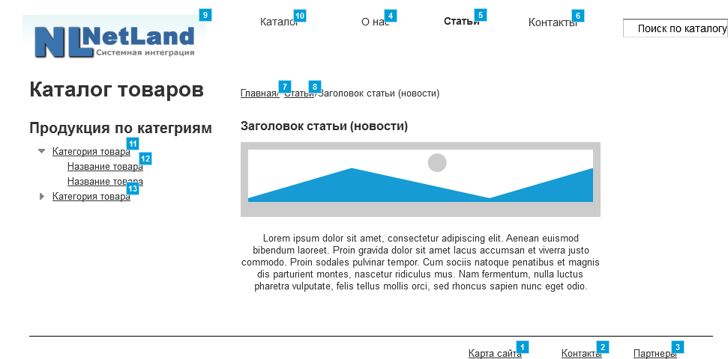

* + 1. Widget Table

|  |  |  |
| --- | --- | --- |
| Footnote | Name | Interactions |
| 1 |  | OnClick:  Case 1:  Open Карта сайта in Current Window |
| 2 |  | OnClick:  Case 1:  Open Контакты in Current Window |
| 3 |  | OnClick:  Case 1:  Open О компании in Current Window |
| 4 |  | OnClick:  Case 1:  Open О компании in Current Window |
| 5 |  | OnClick:  Case 1:  Open Статьи in Current Window |
| 6 |  | OnClick:  Case 1:  Open Контакты in Current Window |
| 7 |  | OnClick:  Case 1:  Open Link in Current Window  Open Главная in Current Window |
| 8 |  | OnClick:  Case 1:  Open Статьи in Current Window |
| 9 |  | OnClick:  Case 1:  Open Главная in Current Window |
| 10 |  | OnClick:  Case 1:  Open Каталог товаров in Current Window OnMouseEnter:  Case 1:  Open Link in Current Window  Show/Hide Widget  Show flowout menu treat as flyout |
| 11 |  | OnClick:  Case 1:  Open Каталог товаров in Current Window |
| 12 |  | OnClick:  Case 1:  Open Название товара по категориям 1 вид in Current Window |
| 13 |  | OnClick:  Case 1:  Open Каталог товаров in Current Window |

* + 1. flowout menu
       1. State1
       2. User Interface



* + - 1. Widget Table

|  |  |
| --- | --- |
| Footnote | Interactions |
| 1 | OnClick:  Case 1:  Open Каталог товаров in Current Window |
| 2 | OnClick:  Case 1:  Open Каталог товаров in Current Window |

* 1. Контакты
     1. User Interface

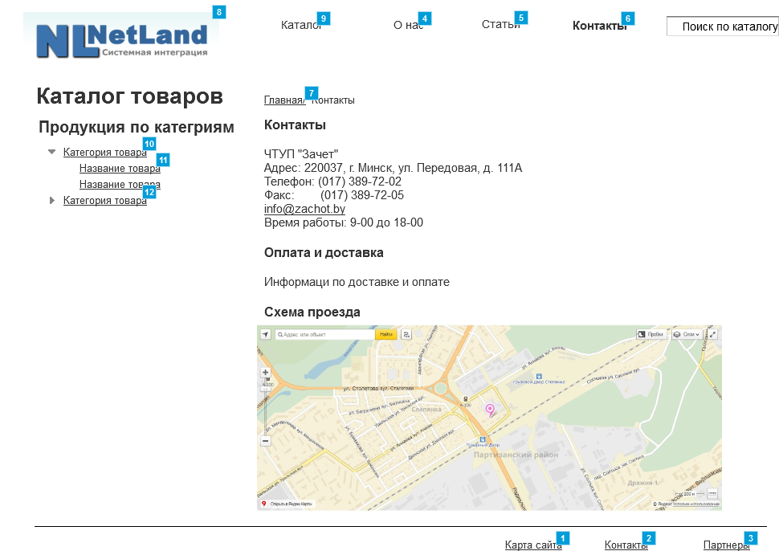

* + 1. Widget Table

|  |  |  |
| --- | --- | --- |
| Footnote | Name | Interactions |
| 1 |  | OnClick:  Case 1:  Open Карта сайта in Current Window |
| 2 |  | OnClick:  Case 1:  Open Контакты in Current Window |
| 3 |  | OnClick:  Case 1:  Open О компании in Current Window |
| 4 |  | OnClick:  Case 1:  Open О компании in Current Window |
| 5 |  | OnClick:  Case 1:  Open Статьи in Current Window |
| 6 |  | OnClick:  Case 1:  Open Контакты in Current Window |
| 7 |  | OnClick:  Case 1:  Open Link in Current Window  Open Главная in Current Window |
| 8 |  | OnClick:  Case 1:  Open Главная in Current Window |
| 9 |  | OnClick:  Case 1:  Open Каталог товаров in Current Window OnMouseEnter:  Case 1:  Open Link in Current Window  Show/Hide Widget  Show flowout menu treat as flyout |
| 10 |  | OnClick:  Case 1:  Open Каталог товаров in Current Window |
| 11 |  | OnClick:  Case 1:  Open Название товара по категориям 1 вид in Current Window |
| 12 |  | OnClick:  Case 1:  Open Каталог товаров in Current Window |

* + 1. flowout menu
       1. State1
       2. User Interface



* + - 1. Widget Table

|  |  |
| --- | --- |
| Footnote | Interactions |
| 1 | OnClick:  Case 1:  Open Каталог товаров in Current Window |
| 2 | OnClick:  Case 1:  Open Каталог товаров in Current Window |

* 1. Карта сайта
     1. User Interface

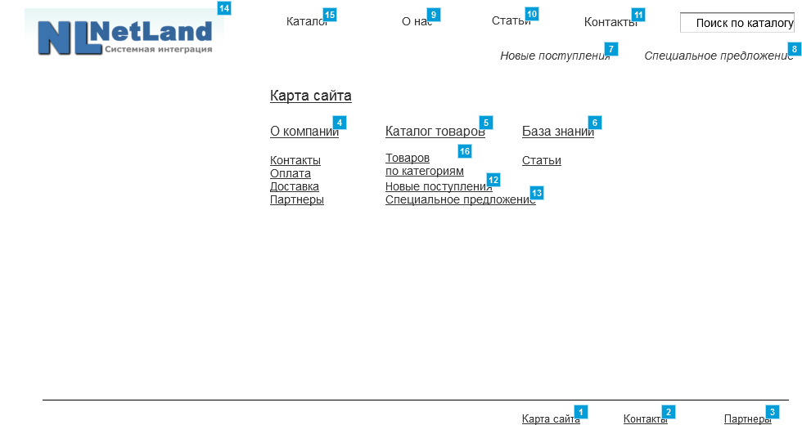

* + 1. Widget Table

|  |  |  |
| --- | --- | --- |
| Footnote | Name | Interactions |
| 1 |  | OnClick:  Case 1:  Open Карта сайта in Current Window |
| 2 |  | OnClick:  Case 1:  Open Контакты in Current Window |
| 3 |  | OnClick:  Case 1:  Open О компании in Current Window |
| 4 |  | OnClick:  Case 1:  Open О компании in Current Window |
| 5 |  | OnClick:  Case 1:  Open Каталог товаров in Current Window |
| 6 |  | OnClick:  Case 1:  Open Статьи in Current Window |
| 7 |  | OnClick:  Case 1:  Open Новые поступления in Current Window |
| 8 |  | OnClick:  Case 1:  Open Link in Current Window |
| 9 |  | OnClick:  Case 1:  Open О компании in Current Window |
| 10 |  | OnClick:  Case 1:  Open Статьи in Current Window |
| 11 |  | OnClick:  Case 1:  Open Контакты in Current Window |
| 12 |  | OnClick:  Case 1:  Open Новые поступления in Current Window |
| 13 |  | OnClick:  Case 1:  Open Специальное предложение in Current Window |
| 14 |  | OnClick:  Case 1:  Open Главная in Current Window |
| 15 |  | OnClick:  Case 1:  Open Каталог товаров in Current Window OnMouseEnter:  Case 1:  Open Link in Current Window  Show/Hide Widget  Show flowout menu treat as flyout |
| 16 |  | OnClick:  Case 1:  Open Название товара по категориям 1 вид in Current Window |

* + 1. flowout menu
       1. State1
       2. User Interface



* + - 1. Widget Table

|  |  |
| --- | --- |
| Footnote | Interactions |
| 1 | OnClick:  Case 1:  Open Каталог товаров in Current Window |
| 2 | OnClick:  Case 1:  Open Каталог товаров in Current Window |